Design of order price calculation

Overview
It’s a service that takes JSON text as input and returns detail price as out put.
Each product has it’s ID number.
Data base contains price of each product, and definitions of promotions.
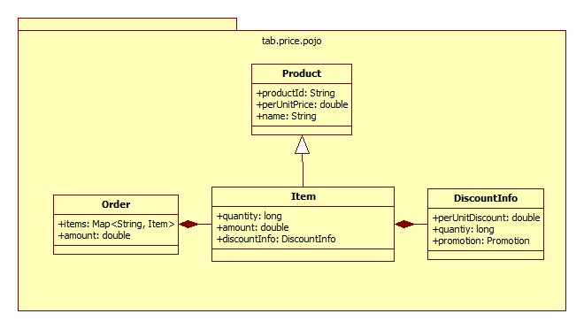
Pricing service invokes:
- JSON parser to parse JSON to order instance.
- Pricing Engine to query price of each product and apply promotions.
- Price formatter to format order instance to string.

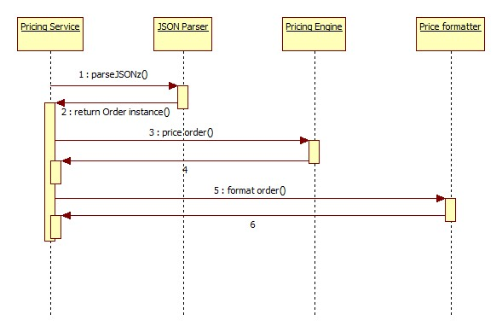

JSON Parser
Class JsonInpujtParser implements InputParser interface. It supports JSON format.
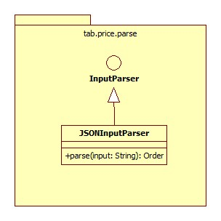
Use gson-2.6.2 to parse from input string to java object.
Set following Properties of order when parsing input:
- items
- Items[n].productId
- Items[n].quantity

Pricing Engine
Pricing engine takes 3 steps to calculate price of whole order.
- Query product info of each item. Includes product name and per-unit-price.
Set following Properties of order when querying product info:
- Items[n].name
- Items[n].perUnitPrice
- Apply promotions to items, different promotions has different priorities. Only one promotion has been applied to one item. Now we supports 2 types of item promotions:
  - Buy M get N: ‘M’ and ‘N’ stands for quantity of same product in order. For every M in order, get N free.
  - Discount a product by rate: Some product get discount by rate.
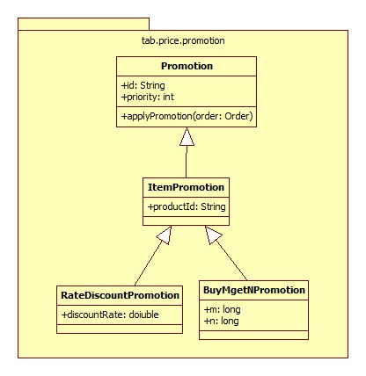
Set following Properties of order when applying promotions:
- Items[n].discountInfo
- Items[n].discountInfo.quantity
- Items[n].discountInfo.perUnitDiscount
- Items[n].discountInfo.promotion

- Calculate amount of each item and total amount of order.
Set following Properties of order when applying promotions:
- Items[n].amount
- amount

